**Noman Khan Assignments Day 6**

**Assignment 1:** Ensure the script checks if a specific file (e.g., myfile.txt) exists in the current directory. If it exists, print "File exists", otherwise print "File not found".

CODE:

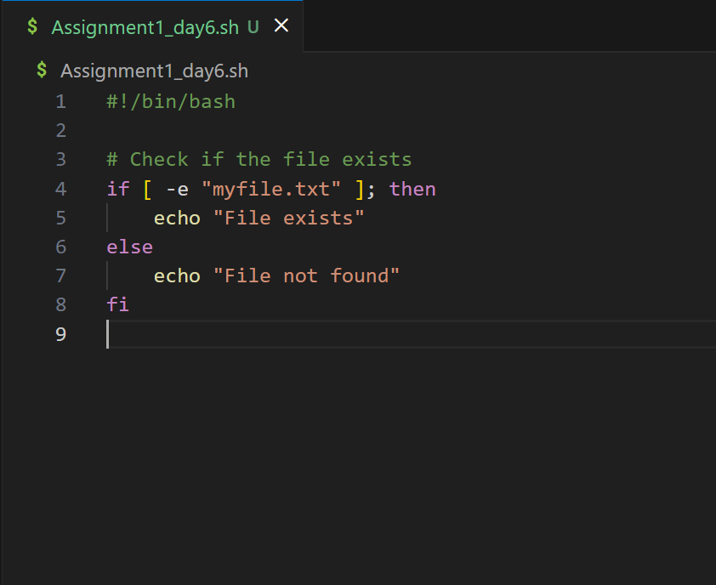

OUTPUT:

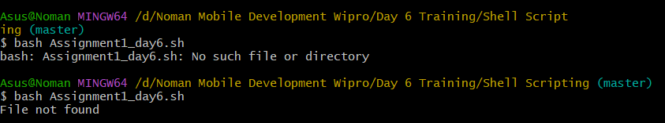

**Assignment :** Write a script that reads numbers from the user until they enter '0'. The script should also print whether each number is odd or even. shell scripting

CODE:

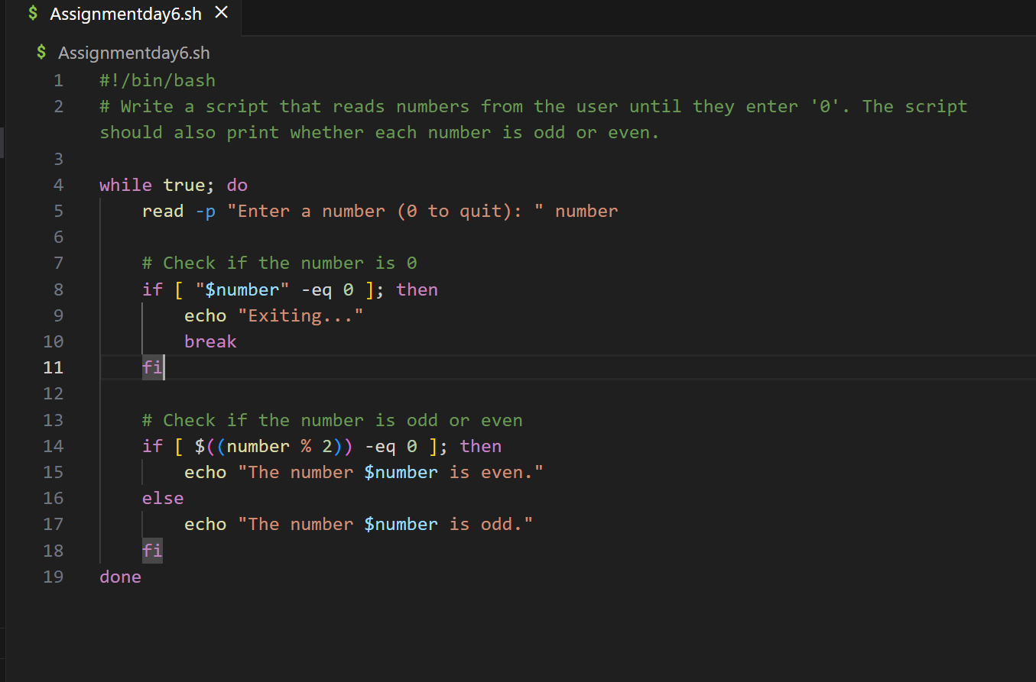

OUTPUT:

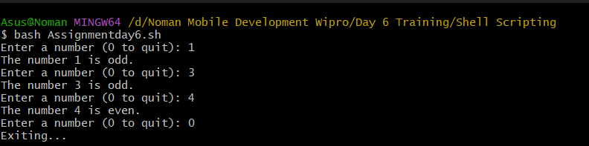

**Assignment 3:** Create a function that takes a filename as an argument and prints the number of lines in the file. Call this function from your script with different filenames.

CODE:

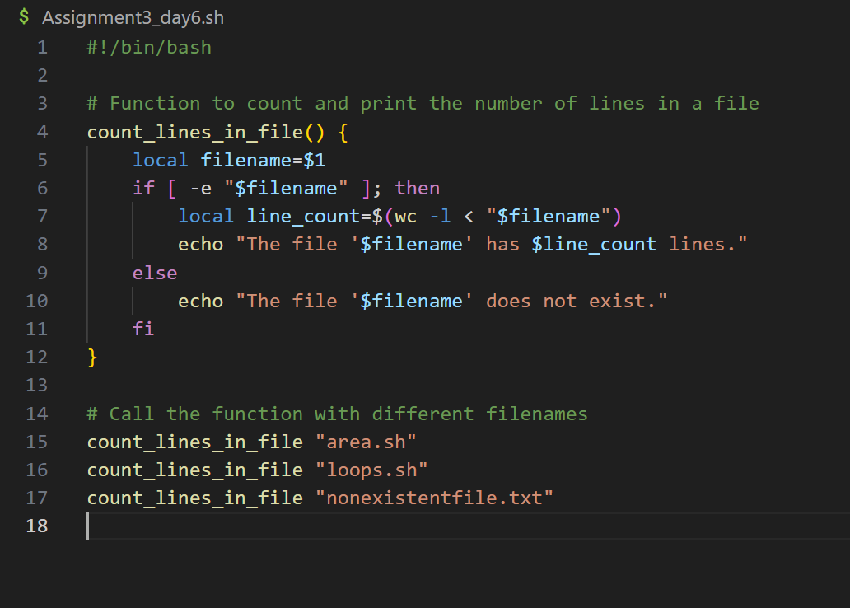

OUTPUT:

